Feature Enginerring

Feature engineering is the process of turning raw data into useful features that help improve the performance of machine learning models. It includes choosing, creating and adjusting data attributes to make the model’s predictions more accurate. The goal is to make the model better by providing relevant and easy-to-understand information.

Importance of Feature Engineering
Feature engineering can significantly influence model performance. By refining features, we can:
Improve accuracy: Choosing the right features helps the model learn better, leading to more accurate predictions.
Reduce overfitting: Using fewer, more important features helps the model avoid memorizing the data and perform better on new data.
Boost interpretability: Well-chosen features make it easier to understand how the model makes its predictions.
Enhance efficiency: Focusing on key features speeds up the model’s training and prediction process, saving time and resources.

Processes Involved in Feature Engineering
Lets see various features involved in feature engineering:

1. Feature Creation: Feature creation involves generating new features from domain knowledge or by observing patterns in the data. It can be:
Domain-specific: Created based on industry knowledge like business rules.
Data-driven: Derived by recognizing patterns in data.
Synthetic: Formed by combining existing features

2. Feature Transformation: Transformation adjusts features to improve model learning:
Normalization & Scaling: Adjust the range of features for consistency.
Encoding: Converts categorical data to numerical form i.e one-hot encoding.
Mathematical transformations: Like logarithmic transformations for skewed data.

3. Feature Extraction: Extracting meaningful features can reduce dimensionality and improve model accuracy:
Dimensionality reduction: Techniques like PCA reduce features while preserving important information.
Aggregation & Combination: Summing or averaging features to simplify the model.

4. Feature Selection: Feature selection involves choosing a subset of relevant features to use:
Filter methods: Based on statistical measures like correlation.
Wrapper methods: Select based on model performance.
Embedded methods: Feature selection integrated within model training.

5. Feature Scaling: Scaling ensures that all features contribute equally to the model:
Min-Max scaling: Rescales values to a fixed range like 0 to 1.
Standard scaling: Normalizes to have a mean of 0 and variance of 1.

Steps in Feature Engineering
Feature engineering can vary depending on the specific problem but the general steps are:
Data Cleaning: Identify and correct errors or inconsistencies in the dataset to ensure data quality and reliability.
Data Transformation: Transform raw data into a format suitable for modeling including scaling, normalization and encoding.
Feature Extraction: Create new features by combining or deriving information from existing ones to provide more meaningful input to the model.
Feature Selection: Choose the most relevant features for the model using techniques like correlation analysis, mutual information and stepwise regression.
Feature Iteration: Continuously refine features based on model performance by adding, removing or modifying features for improvement.

Feature Extraction
Feature extraction is an important technique used in machine learning and data analysis to transform raw data into a set of features that are easier for algorithms to work with. By reducing the complexity of the data, it keeps only the important parts and discards the unnecessary details.

This allows machines to process data more efficiently and helps improve the accuracy of models. In many fields like image processing, natural language processing and signal processing, raw data often comes with multiple characteristics. Many of these might be redundant or irrelevant. Feature extraction helps simplify this data, retaining only the most useful information for analysis.

Why is Feature Extraction Important?
Feature extraction is important for several reasons:
Reduced Computation Cost: Raw data, especially from images or large datasets can be very complex. Feature extraction makes this data simpler, reducing the computational resources needed for processing.
Improved Model Performance: By focusing on key features, machine learning models can work with more relevant information, leading to better performance and more accurate results.
Better Insights: Reducing the number of features helps algorithms concentrate on the most important data, eliminating noise and irrelevant information which can lead to deeper insights.
Prevention of Overfitting: Models with too many features may become too specific to the training data, making them perform poorly on new data. Feature extraction reduces this risk by simplifying the model.

Principal Component Analysis(PCA)

PCA (Principal Component Analysis) is a dimensionality reduction technique used in data analysis and machine learning. It helps you to reduce the number of features in a dataset while keeping the most important information. It changes your original features into new features these new features don’t overlap with each other and the first few keep most of the important differences found in the original data.

PCA is commonly used for data preprocessing for use with machine learning algorithms. It helps to remove redundancy, improve computational efficiency and make data easier to visualize and analyze especially when dealing with high-dimensional data

How Principal Component Analysis Works

PCA uses linear algebra to transform data into new features called principal components. It finds these by calculating eigenvectors (directions) and eigenvalues (importance) from the covariance matrix. PCA selects the top components with the highest eigenvalues and projects the data onto them simplify the dataset.

- Standardize the Data
2. Compute the Covariance Matrix
3. Compute the Eigenvalues and Eigenvectors
4. Sort Eigenvalues and Select Principal Components
5. Project the Data onto the New Feature Space
6. Analyze or Visualize the Result

What Are Principal Components?

Principal components are new variables that are constructed as linear combinations or mixtures of the initial variables. These combinations are done in such a way that the new variables (i.e., principal components) are uncorrelated and most of the information within the initial variables is squeezed or compressed into the first components. So, the idea is 10-dimensional data gives you 10 principal components, but PCA tries to put maximum possible information in the first component, then maximum remaining information in the second and so on, until having something like shown in the scree plot below.

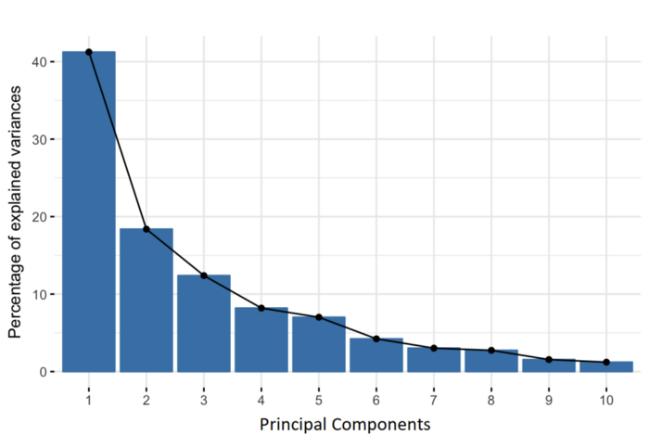

from sklearn.decomposition import PCA
pca = PCA(n_components=None) # Reduce to 2 components
X_pca = pca.fit_transform(x)

print("Explained variance ratio:", pca.explained_variance_ratio_)
print("Total variance explained:", np.sum(pca.explained_variance_ratio_))

LDA (linear Discriminant Analysis):-

Linear discriminant analysis (LDA) is an approach used in supervised machine learning to solve multi-class classification problems. LDA separates multiple classes with multiple features through data dimensionality reduction. This technique is important in data science as it helps optimize machine learning models.

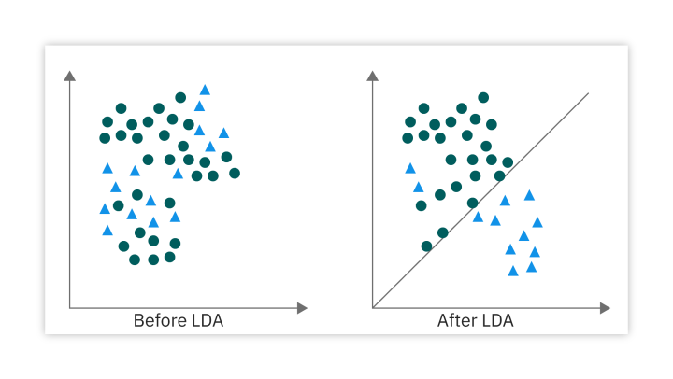

the two features or classes are plotted on a 2-dimensional (2D) plane with an X-Y axis. If we tried to classify approvals using just one feature, we might observe overlap. By applying LDA, we can draw a straight line that completely separates these two class data points. LDA achieves this by using the X–Y axis to create a new axis, separating the different classes with a straight line and projecting data onto the new axis.
To create this new axis and reduce dimensionality, LDA follows these criteria:
Maximize the distance between the means of two classes.
Minimize the variance within individual classes.

How the linear discriminant function works

Calculate the between-class variance
The between-class variance is the separability between classes—the distance between the class means.
Calculate the within-class variance
The within-class variance is the distance between class means and samples.
Project the data into a lower-dimensional space
his maximizes the between-class variance and minimizes the within-class variance. We can represent the linear discriminant function for two classes mathematically with the following
δ(x) = x * ( σ2 * (μ0-μ1) - 2 * σ2 * (μ02-μ12) + ln(P(w0) / P(w1)))
Where:
δ(x) represents the linear discriminant function.
x represents the input data point.
μ0 and μ1 are the means of the two classes.
σ2 is the common within-class variance.
P(ω0) and P(ω1) are the prior probabilities of the two classes.

from sklearn.discriminant_analysis import LinearDiscriminantAnalysis
lda = LinearDiscriminantAnalysis)
= lda.fit()

Python is a programming language which is used to interact with computers.

Python is a high level programming language.

Programming language
- high level : human easily understand
- Low level : computer easily understand

Python is a interpreted language.
- Compiler:
- Interpreter:

- Python is a case sensitive language.
- upper case: capital letters Ato Z
- Lower case:small letters a to z

print,True,False

4.Python is a simple to learn,its syntax like simple english.

- python has large predefined libraries.

Applications:
- web developent
- Data science
- Machine learning,deep learning,

- game development

